**Use-case diagram**

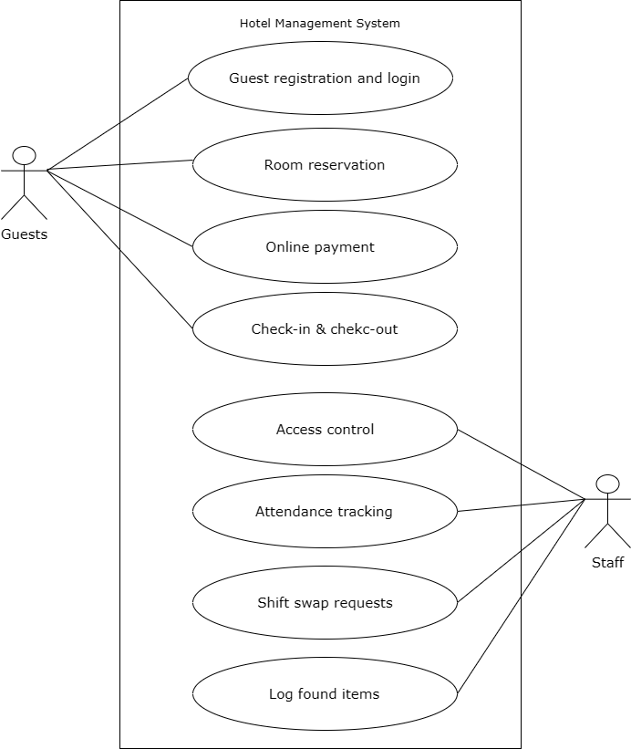

Figure 1.1 for hotel management system

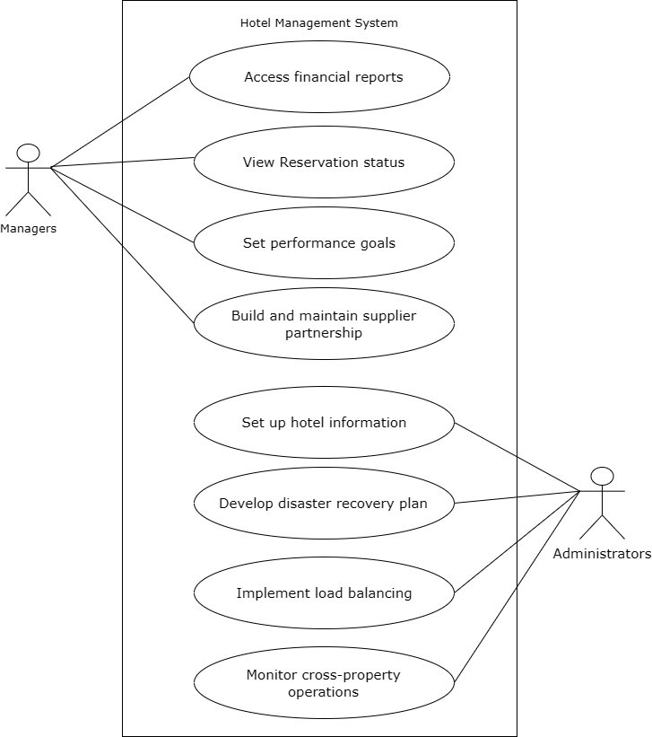

Figure 1.2 for hotel management system